The Role of Gift Giving in Treaties
Ashley Zerne

Abstract
Prestige goods is an anthropological term that describes items a society has ascribed value to. For the native peoples of Pennsylvania and Delaware, this included trade goods from Europeans and shell beads known as Wampum, which were often strung together to make belts. Perhaps the most famous example Wampum belt is the one that was presented to William Penn, the founder and original Proprietor of Pennsylvania, in 1683. Gift exchange played an integral role throughout the act of treaty making between Native Americans and European settlers in Pennsylvania during the 1700’s. The exchange of prestige goods served to strengthen relationships and record important agreements.

To understand the role of gift exchange in negotiations between Native Americans and Europeans, one must first look at the history of prestige goods as relating to the area this paper focuses on. A classic anthropological definition of chiefdoms describes them as “redistribution societies.” Their politics and economy relied on the leaders’ ability to maintain their agency through the control of resources (Richter, 2017). Prestige goods served as a source of wealth that could not be separated from the places where they originated. This included items that were traded from far away, or items that could only be found in specific places and in rare quantities. In short, these items were considered special and exotic. Chiefs maintained power by controlling the sources of these items as well as the interactions with outside traders. Early examples of prestige goods include shells, copper, and crafted items thought to have served ritual purposes. The power came not from the item itself, but the place, or people, it originated from. By the time Pennsylvania was granted to William Penn in 1682, the prestige goods economy had evolved. Trade items from Europe had become increasingly available, yet the symbolic importance of these prestige goods remained.
Strings of Wampum Beads, from the Penn Museum collections

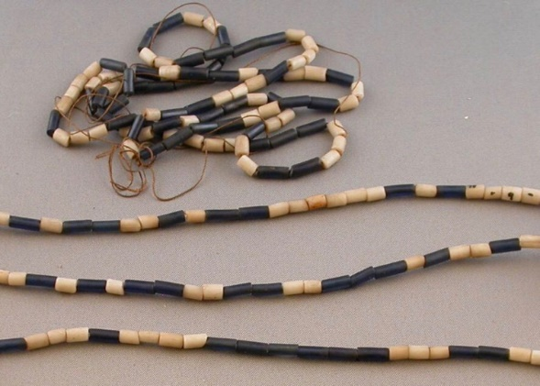
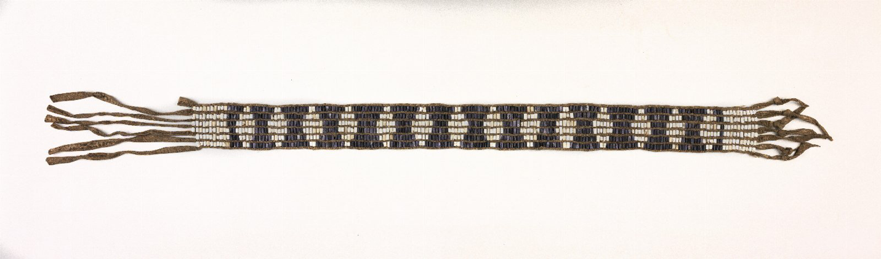
In the case of Wampum, or wampumpeag, the shell beads—which were an exotic substance to people who lived further inland—were originally considered gifts from an underwater spirit realm (Richter, 2005). In the early 1600’s, these white and black (actually purple) beads were made in an assortment of shapes and sizes from the shells of whelk and quahog clams found primarily on the coast of New England. It was not until Dutch traders introduced iron tools and standardization that the uniform tubular beads that are considered “true wampum” came to be (Richter, 2005). With these new innovations, the Algonquian people were able to produce thousands of beads which were traded to the Dutch and then re-traded to Indians further inland. By the time William Penn set foot on Pennsylvanian soil, the Wampum beads had become integral to the religious and political life of the Lenape and the Iroquois (Richter, 2005). These were the groups the Provincial Council of Pennsylvania set out to make treaties with. Wampum, along with other prestige goods, played an important role in strengthening that chain of friendship
A Wampum Belt, from the Penn Museum collections

Wampum was used in several ways. When woven into belts, they could record alliances, serve as symbols of authority and legitimacy, and perhaps even purify and protect groups and treaties from negative forces (Pencak, 2004). The Delaware Indians referred to the beads by saying “wampum is our heart” (Speck, 1931). To them, Wampum was a type of spiritual medicine and was given not because of its monetary value, but for its power—to heal the spirits of those entering negotiations (Speck, 1931). Strings of wampum were often given during speeches to confirm notions of goodwill. Gifts of clothing and animal skins also held special significance. Both the English and Native Americans exchanged cloth goods to signify their relationships to each other (Johnson, 2009). Gifts of skins were also considered valuable as the fur trade was the backbone of the Pennsylvanian economy.
This chain of friendship did not come without its complications, especially as Indians and Europeans had very different understandings of how these types of negotiations would take place. While the Provincial council and its members were primarily concerned with the end product of negotiations—the written treaty— the Lenape and Iroquois cared more about the process, which included exchanging gifts as a sign of goodwill and brotherhood (Merrell, 2008). What the English saw as bribes for good behavior, native people saw markers that sealed relationships (Richter, 2017). Whether or not they agreed with the practice, to achieve the peaceable kingdom William Penn had envisioned, talks with Indians needed to follow Indian customs.
To better understand the way gift-giving was built into the structure of negotiations between Indians and Europeans, this paper will now examine a treaty with the Six Nations that occurred in 1732. For convenience, excerpts from the treaty are included below with original spelling and grammar.
Treaty councils lasted for many days; it was a process that could not be rushed, as Indians considered every moment to be important for creating an atmosphere of peace for all involved (Merrell, 2008). Gifts were exchanged over several days and for specific purposes. Wampum were used to reaffirm goodwill, and record the results, while articles of clothing and skins were used to signify a strengthening of relationships between groups (Johnson, 2009). The first strand of wampum is presented as a sign of authority, that those present could speak for those unable to attend the council. A few days later, the Indians reaffirm their intentions to remain friends with the English by being open about their dealings with the French and presenting another string of Wampum, as well as the otter skins that were placed over the shoulders of Thomas Penn. On August 28th, the Indian’s speaker laid down a string of wampum as though to strengthen and protect the spiritual goodwill that had been established so far. A day later the English were asked to make a wampum belt—a record of their treaty—to be sent back to the rest of the Nations. The English not only complied, but also gifted two matchcoats to confirm their own intentions. On the last days of the treaty, the English presented two wampum belts along with a present of several different types of trade goods, and the Indians responded with a bundle of skins.
Exchanging gifts was not just an aspect of the treaty, it was integral. Intentions were marked with physical symbols, and agreements solidified not just with the exchange of goods, but with acts of friendship and brotherhood. To give something during negotiations was to show that the relationship held value—by not participating, one would be denying those good intentions. The relationship between the Provincial Council and the Iroquois relied on these gifts. In simple terms, without gift exchange, there would be no negotiations or treaties, and the fur trade that supplied the Pennsylvanian economy would have crumbled.

References

Johnson, Laura. (2009). Goods to clothe themselves: Native Consumers and Native Images on
the Pennsylvania Trading Frontier, 1712-1760. Winterthur Portfolio, Vo1 43, No. 1, Pages 115-140.
Kent, Donald. (1983). Early American Indian documents: treaties and Laws, Vol 1: Pennsylvania
and Delaware treaties, 1629-1737.
Pencak, W., & Richter, D. K. (2004). Friends and enemies in Penns Woods: Indians, colonists,
and the racial construction of Pennsylvania. University Park, PA: Pennsylvania State University Press.
Richter, D. (2005) . Native American’s Pennsylvania: Pennsylvania Historical Association.
Richter, D. (2017). Trade, land, power: The struggle for eastern North America. Philadelphia:
University of Pennsylvania Press.
Speck, Frank. (1931). A Study of the Delaware Indian Big House Ceremony: Pennsylvania
Historical Commission.
Merrell, James. (2008). The Treaty of Lancaster 1744 with Related Documents: Vassar College

Recommended Citation
Zerne, A. (2019). The Role of Gift Giving in Treaties. Made in Millersville Journal, 2019. Retrieved from https://www.mimjournal.com

Documents
PROVINCIAL COUNCIL: TREATY WITH SIX NATIONS
(Col. Recs., III, 435-452)
[Aug-Sept., 1732]

At a Council held at Philadelphia, August 23d, 1732.

THE PROPRIETOR, by Conrad Weyser the Interpreter, spoke to the Indians as follows:
“My Friends and Brethren:
It is a great Pleasure to me that within so few days, not more than Six after my Arrival at Philadelphia, from a Voyage of some thousands of Miles over the Great Sea, I had the good Fortune to meet my Brethren, the Chiefs of the Five Nations, here. I need not inform you that when my Father, William Penn, was sent by the Great King of England to bring over large Numbers of his People to Settle in this Country, he made it his first and principal Care to convince all the Indians Inhabiting it, that came with a full Design to their Friend and Benefactor. He was not only just to then, in buying and paying for so much of their Lands as he then wanted, but in all things he treated them with Tenderness and Affection, he loved them as his Children, he became their Father. And he entered into the Strictest League of Amity with them, not only between himself and his People and the Indians then living, but to continue between his Children and their Children and their Posterity of all Generations, and for this Purpose he made with them a Chain of Friendship, to be kept Strong and bright forever. And when his Affairs in England obliged him to leave this Country, he gave it strictly in Charge to all his Governors and People in Power under him, that they should in the same manner treat all the Indians as he had done. That they should be as Fathers to them, and that all his People should live in perfect Peace and Brotherhood with all the Indians, as if they were of one Blood and of one Body, without distinction…”

...After which HETAQUANTAGECHTY, their Speaker, said:
That since their Brother ONAS is now come amongst them, and that they have the Satisfaction of seeing him and the Governor together, they will speak to them both in the manner that is desired. And producing some Strings of Wampum he gave them to the Proprietor, and said that these had been sent from this Government by Shekellamy with a Message inviting some Chiefs of their Several Nations to come to Philadelphia; that there are now only some Chiefs of three of their Nations presents, viz.: of the Tsanandowas, Cayoogoes, and Oneidas, but that these are fully impowered and otherized to treat and speak in behalf of them all.

—

At a Council held at Philadelphia, August 25th, 1732.

...That they Know nothing certainly of what passed between Cahichtodo and the Shawanese at Ohio.
Then presenting some Strings of Wampum,
They said, that since their Brother Onas and their Brother the Governour, had treated and received them so Kindly, and had spoke to them in so friendly a manner, they were highly pleased with the same, and are very willing and desirous that ther may be more frequent Opportunities of conferring and discoursing with their Brethren, and that these may be managed by the Means of Shekellamy and Conrad Wyser, the Interpreter….

The Speaker presenting the Proprietor with a fine painted Mantle of dresst Otter skins, putt the same over his Shoulders.

—

At a Council held at Philadelphia, Aug 28th, 1732.

HETAQUANTEGECHTY repeating what had been proposed to them at the Conference, said:
That they had taken time to consider of their answer touching the Shawanese, which they would now deliver to their Brother Onas and the Governour.
That they are much indebted to their Brethren for the goodwill and affection they show, in advising them to strengthen themselves by friendship with their Neighbors of Several Nations; that they look upon this Advice as a Sure Token of Brotherly Love towards them.
Then Laying down some strings of Wampum:
They desire we all joyn with them in calling back the Shawanese, which they conceive they can do by preventing our Indian Traders from going to Ohio, for while the Indians are supplyed at that place with such Goods as they want, they will be the more unwilling to remove…
—

August 29th.

“My Brethren:
We have considered your Answer accompanyed by some Strings of Wampum, to our Proposition of recalling the Shawanese. We are much obliged to you for the Readiness you show to Joyn with us in this matter, and we are desirous to have the same putt in Execution as soon as may be…
...Therefore we would propose, that till next Spring we should delay calling back our Traders, and likewise that the Indians for the aforementioned Reasons, be suffered to continued there till that time and no longer. And to confirm these Words, we give you one Stroud Matchcoat.
As to what you have said about employing Shekellamy and Conrad Weyser, on which you gave the first strings of Wampum, We are very glad you agree with us in the Choice of so good Men to go between us. We believe them to be very honest, and with Chearfulness employ them, and to confirm this we give another Stroud Matchcoat.
Since you think fitt to desire some Token from us to accompany your intended message to the Shawanese, We now give you a large Belt of Wampum to be delivered to them, together with the Words that have been spoken, that concern that Nations.”

—

At a Council held at Philadelphia, in the Great Meeting house, August 31st, 1732.

“...5th. We will constantly keep a Fire for you here at Philadelphia, that when any of the Chiefs of your Nations come hither, we may sitt down together round it, and advise and consult of such Affairs as may be for the general Interest of both you and us.
“On this Article was delivered a Belt of Wampum.
“6th. And we now desire, there may be an open Road between Philadelphia and the Towns of the Six Nations, which we will on our parts, clear from every Grub, Stump and Log, that it may be straight, smooth and free for us and you. We shall receive all you People and you Allies who come by that Road, as our Friends and Brethren. And as you desire us, Conrad Weyser and Shekellamy shall travel that Road between us and you, who will speak our Minds and your Minds to each other truly and freely.
“On this Article was delivered another Belt of Wampum.
“7th. This Leage and Chain of Friendship ad Brotherhood, we now make with all the Six Nations, viz.: the Tsanandowans, Onandagoes, Ganyingoes, Cayoogoes, Oneidas and Tuscarores, for us and all our People, and for our Children and CHildren’s Children, with you for all you Nations, and for your Children and Children’s Children to all Generations, to continue so long as the Heavens, Sun, Moon, Stars and the Earth shall Endure. And we desire that the same may at your return be ratified and confirmed at you great Fire by all your People, and be kept in perpetual Remembrance, and that all our Indians and all the Nations of Indians in Alliance with you, may be comprehended within the same.
“And for the Confirmation hereof, we now make you this Present:
- Five whole Pieces and ten Stroud Matchcoats,
- One while Piece and ten Duffells,
- Two whole pieces of Blanketting,
- Three hundred pounds of Powder,
- Five hundred wt. Bulletts,
- Ten Guns,
- Three hundred Flints,
- Three dozen Shirts,
- Six Coats,
- Twelve pair of Shoes and Buckles,
- Twelve pair of Stockings,
- Ten Kettles
- Ten dozen of Knives,
- Five dozen of Scissars,
- Five dozen of Tobacco tongs,
- Two dozen and one half dozen of Combs,
- Three pound of Vermillion.
- One hundred pound of Tobacco and one Groce of Pipes.
THE PROPRIETOR was pleased to add to the Present, Six fine japanned and gilt Guns, which he brought over with him, to be delivered one to the Chief of Each of the Six Nations.

